Digital Storytelling with Window Movie Maker

CAUTION: SAVE YOUR WORK OFTEN!!! (Note: You will begin with “Save Project” (which is like a rough draft) and then at the end, you’ll “Save Movie,” which is the final step in preparing your movie to be viewed by others.)

Before you start, you need to have your images saved in “My Pictures.” NO GOOGLE IMAGES. Use: http://office.microsoft.com .

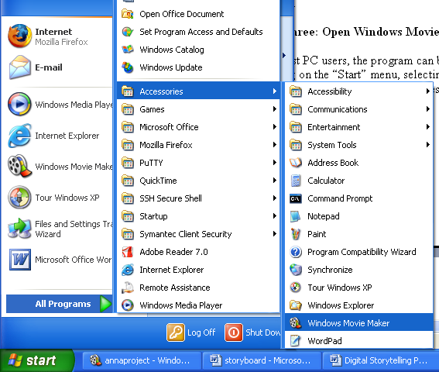
Step One: Open Windows Movie Maker.

Now that you have saved some images and music and completed a storyboard, let’s get going! For most PC users, the program can be found by clicking on the “Start” menu, selecting “All Programs,” and then going to “Accessories.”

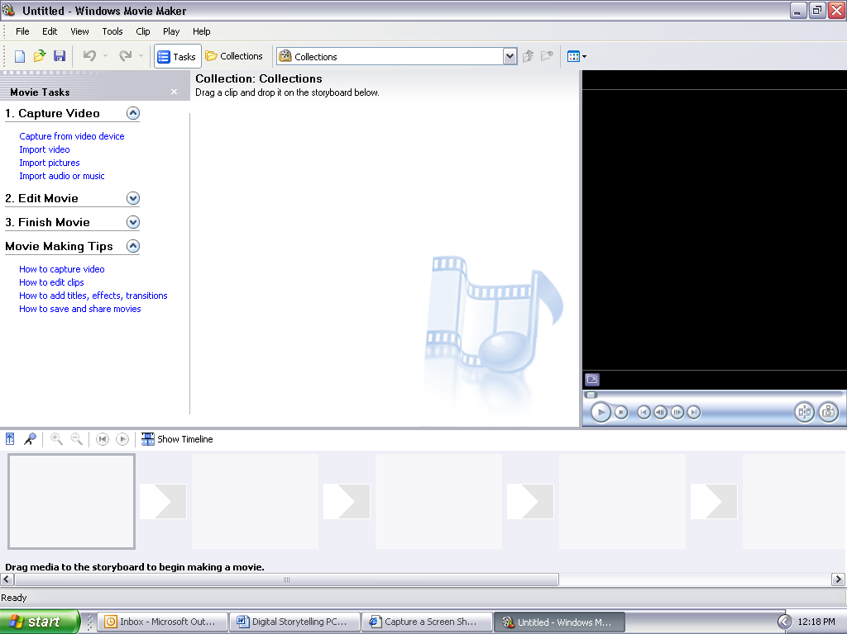
When Movie Maker opens, the screen will typically have four sections, or boxes, displayed in the program window.
- Section one (upper left) will consist of the “Movie Tasks.”
- Section two (upper middle) will be labeled “Collection.” This box displays the files—the “raw materials”—that can be utilized in your movie.
- Section three (upper right) consists of a preview screen, with controls.
- Section four (bottom) depicts the storyboard for your movie.

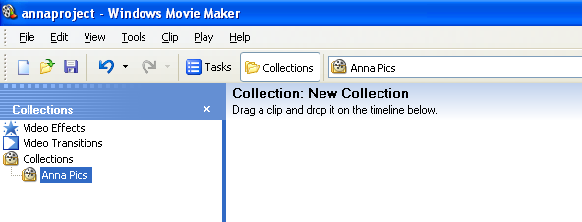
Step Two: Creating a Collection:

On the menu bar along the top of the Movie Maker window, click on the button labeled “Collections.” This will switch your “Movie Task” box to a “Collections” box. In that box, right-click on “Collections” and select “New Collection.” Remember, a collection is just an area in Movie Maker where your images will go before being added into the movie. Give the new collection file a name, such as “Anna Pics,” shown above.

Step Three: Importing Images to Your Collection
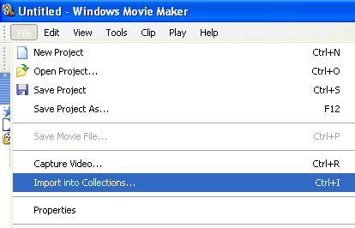
Left-click on the title of your new collection. (The title should become highlighted.) Then, under the "File" menu of MovieMaker, click on "Import into Collections..." (see photo at right). Use the subsequent pop-up box to browse and find the folder containing the images you plan to use in your movie. Click on each image, or select all, and then import. All the images should now appear in the Collection folder (upper middle box) in MovieMaker (see photo below).
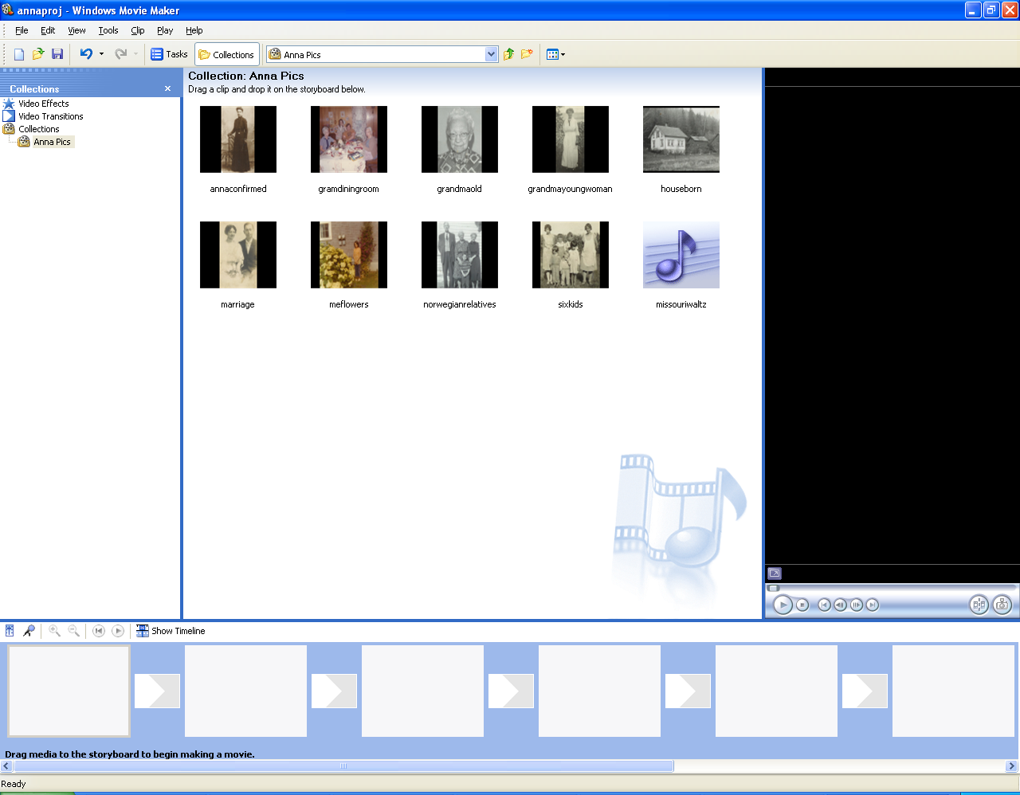

Step Four: Filling Your Movie Maker Storyboard
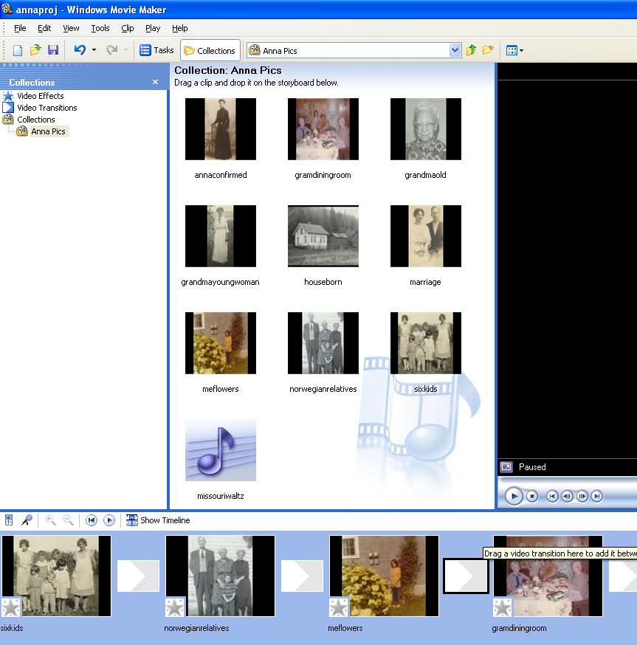
At the bottom of the screen, you should see the Movie Maker storyboard—a series of boxes that will be the frames of your movie. If you don’t see these boxes, look for a button labeled “Show Storyboard” (see below) and click on that button. Now, just click on an image from your collection and drag the image into one of the boxes. Continue dragging and dropping images until you've created the sequence of images you want (see right).
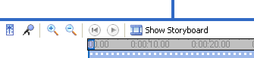

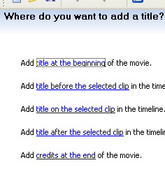
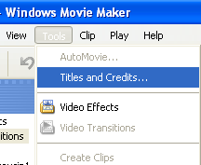
Step Five: Tweaking the Movie

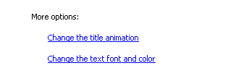
- To add a title to your movie either/or at the start and end, go to "Tools" and then down to "Titles and Credits" and follow the directions for changing title fonts, colors, or animation (see right and below).

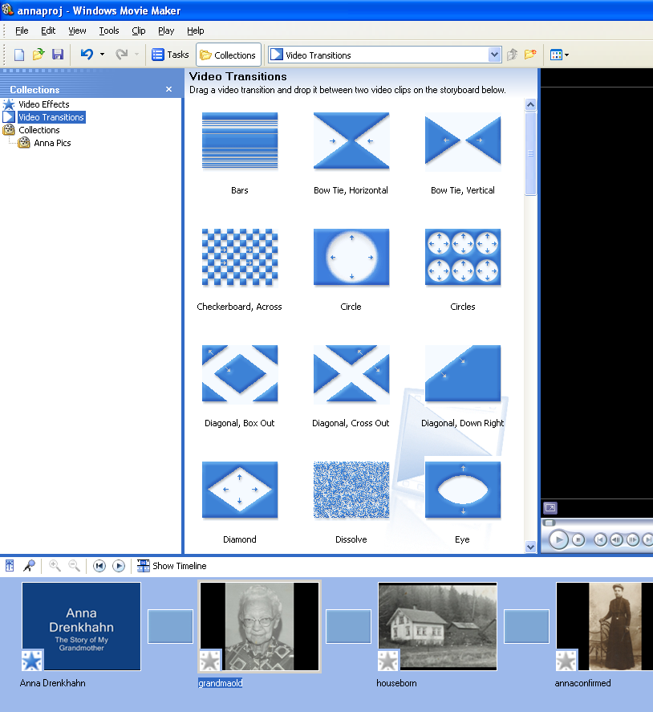

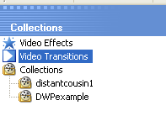
- To add transitions between frames, go to "Video Transitions" beneath the “Collections” heading. Click on your choice of transitions and drag down to the appropriate transition—the area between the two images you want to influence (see right).

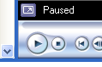
(To preview a transition, click on your choice and
then push the “play button” as shown at right.)

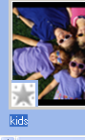
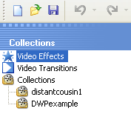
- To add effects to images, go to "Video Effects" beneath “Collections,” and click on your choice of effects and drag down to the small box on the lower left corner of the image you want to be affected (see right). (To preview an effect do the same as transitions – click on your choice, and push the “play button.”)

Step Six: Previewing the Sequence

To (pre)view the sequence, once again, just click on the play button below the little viewing screen on the right side of the window.

Step Seven: Adjusting the Timeline

If you want an image to last longer or shorter on the screen, you first need to click on the "Show Timeline" icon.

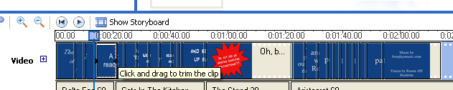
Then click on the right side of the image in the timeline and drag either left or right to make longer or shorter. (When you see the red arrow, you’ll know you can drag or trim the clip. Also, to better see the clips on your timeline,
you can click on the little magnifying glass above “Video”.)

Before “Step Eight,” you must have music saved to “My Music.” Download free music at: http://www.freeplaymusic.com . A 60 second clip is about all you’ll need.

Step Eight: Adding Music
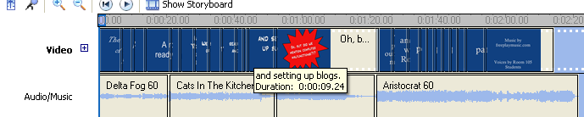
To add music, go back to Step 5 except this time, find the music file you desire and import it. Then click on it, and drag it into the “Audio/Music” space on your timeline. (Click “Show Timeline” to see the “Audio/Music” space.)

To adjust the volume of your music, right click on it. If you’re planning to add narration, turn down the sound quite a bit, or the music will overpower your voice. If you need more music, right click on the music clip. Then copy and paste it right next to the original clip in the Audio/Music line. (Be sure you’ve already adjusted the volume before you copy and paste.)

Step Nine: Save As a Movie

To save your movie, follow these steps CAREFULLY:
- Go to “File,” and click on “Save Movie File.”
- Click on “My Computer” and then “Next.”
- Under “1.” save your movie with an appropriate title.
- Under “2.” make sure it says “My Videos.” Click “Next.”
- Click on the blue “show more choices” link.
- Click the circle beside “Other Settings.”
- Use the blue drop down arrow to find “High quality video (large).” Click “Next.”
- Be patient as the computer saves your movie. Then, click “Finish.”

